<http://baijiahao.baidu.com/s?id=1553525940527619&wfr=spider&for=pc>

**Vector3.Angle（计算两个向量的夹角）**

Vector3 vec1 = objA.transform.position - objEmpty.transform.position;

Vector3 vec2 = objB.transform.position - objEmpty.transform.position;

// 计算以empty为顶点，objA-empty与objB-empty为两条边的夹角

float angle = Vector3.Angle(vec1, vec2);

Debug.DrawLine(objEmpty.transform.position, objA.transform.position, Color.red);

Debug.DrawLine(objEmpty.transform.position, objB.transform.position, Color.green);

Debug.Log("angle = " + angle);

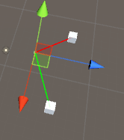



**Vector3.Cross（计算两个向量的叉乘）**

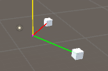

Vector3 vec1 = objA.transform.position - objEmpty.transform.position;

Vector3 vec2 = objB.transform.position - objEmpty.transform.position;

Debug.DrawLine(objEmpty.transform.position, objA.transform.position, Color.red);

Debug.DrawLine(objEmpty.transform.position, objB.transform.position, Color.green);

// 计算以empty为顶点，objA-empty与objB-empty为两条边的叉乘

Vector3 cross = Vector3.Cross(vec1, vec2);

Debug.Log("cross = " + cross);

Debug.DrawLine(objEmpty.transform.position, objEmpty.transform.position + cross, Color.yellow);

**Vector3.Dot（计算两个向量的点乘）**

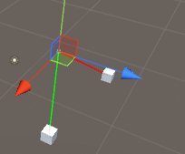

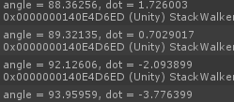

通过点乘我们可以知道两个向量的夹角是锐角还是钝角